**MCIS 6333_002 – Data Visualization Programming**

**Fall 2023 Dr. Esther Ledelle Mead, Professor**

**Assignment 5 (A5)** Module 5 12 points

**Instructions**: Work as a team to fill in your team and team member information. Then continue to work as a team to enter responses for each of the three sections: 1) DVs programmed in Python, 2) DVs programmed in R, and 3) Data insights. Do not change the file name of this template except for adding your Team Number and name at the end of "A5-MCIS6333_002" (for example, "A5-MCIS6333_002-Team_1-Bad-To-The-Bone.docx"). Do not remove any content from this template. **Before submission, be sure that all required components are visible on the final version of your file by expanding their edges as needed and by inserting extra space as needed. Be careful not to move around the objects on this document in a way that messes up the flow. As you add content, the items will be pushed down, which is fine, but be sure to not let any DVs get split up or caught in between two pages. Create as many additional pages on this file as necessary. Turning in work created by students/teams from a past semester will result in a score of zero (0) and an official Academic Dishonesty and Integrity Violation report for each team member to the SAU Authorities.**

**Team #: __1___ Team Name: Datavana  
   
 Contributed effort to this A5? *(Y or N)***

**Team Members (*full names are required*): *Answer required for each team member):*  
1. Revanth Kumar Madasu Yes_  
2. Anusha Pakkiru______________________ Yes__  
*(Remove any unused lines from above.)***

**1) Data visualizations (DVs) programmed in Python that show the Stacked Bar Graphs, Heatmap of Group Comparisons based on Education, Annual Income, Likelihood of using EPS, Likelihood of Themed Party, Likelihood of Destination Party, Budget of Party data**:

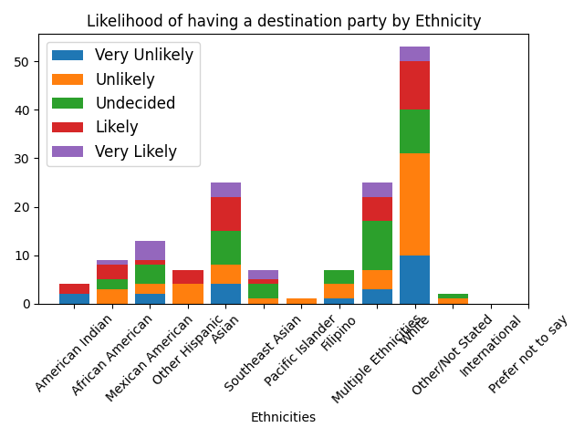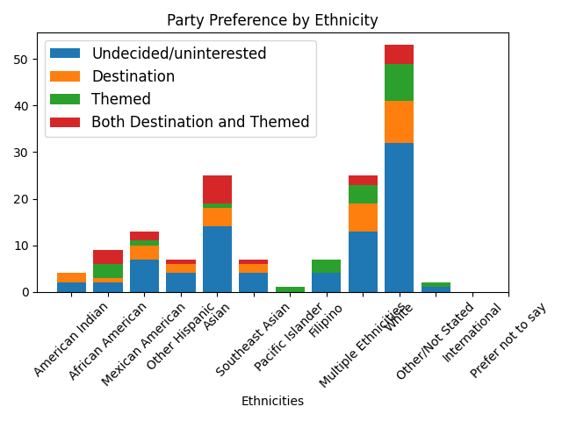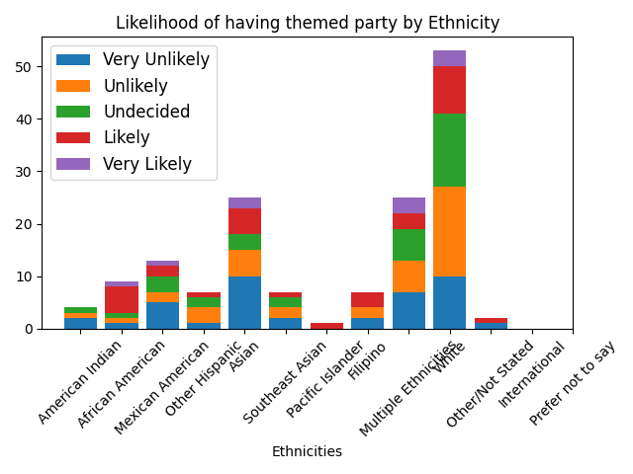

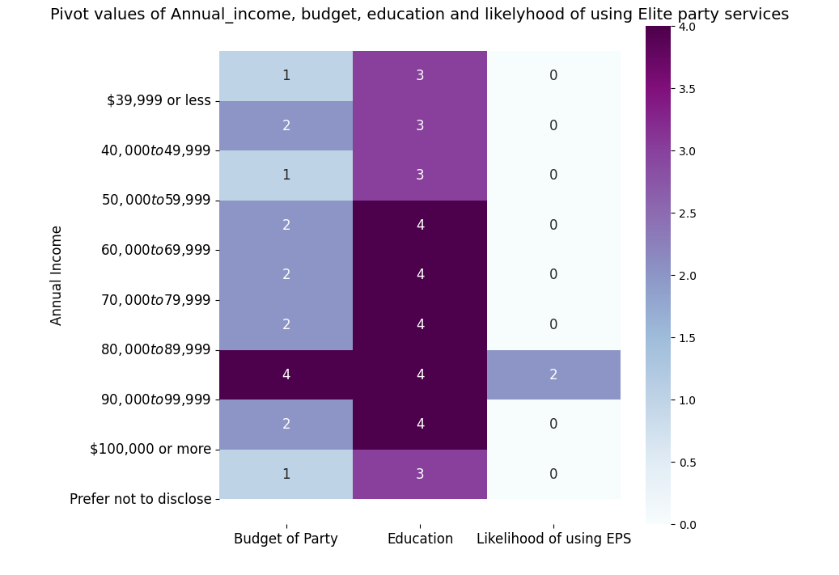

**2) Data visualizations (DVs) programmed in R that show the Stacked Bar Graph, Heatmap of Group Comparisons based on Education, Annual Income, Likelihood of using EPS, Likelihood of Themed Party, Likelihood of Destination Party, Budget of Party data**:

Insert your DVs below this line.

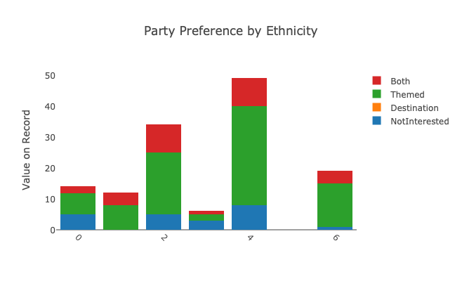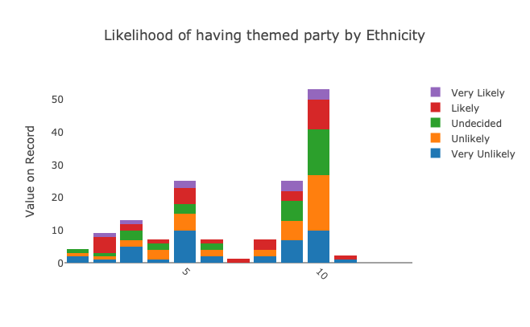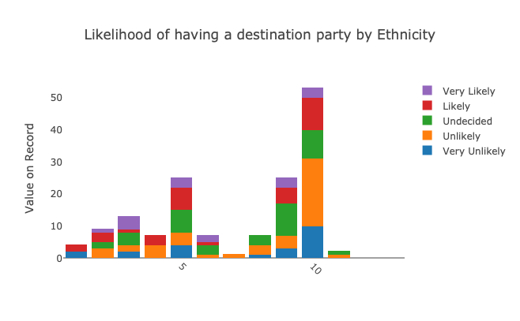

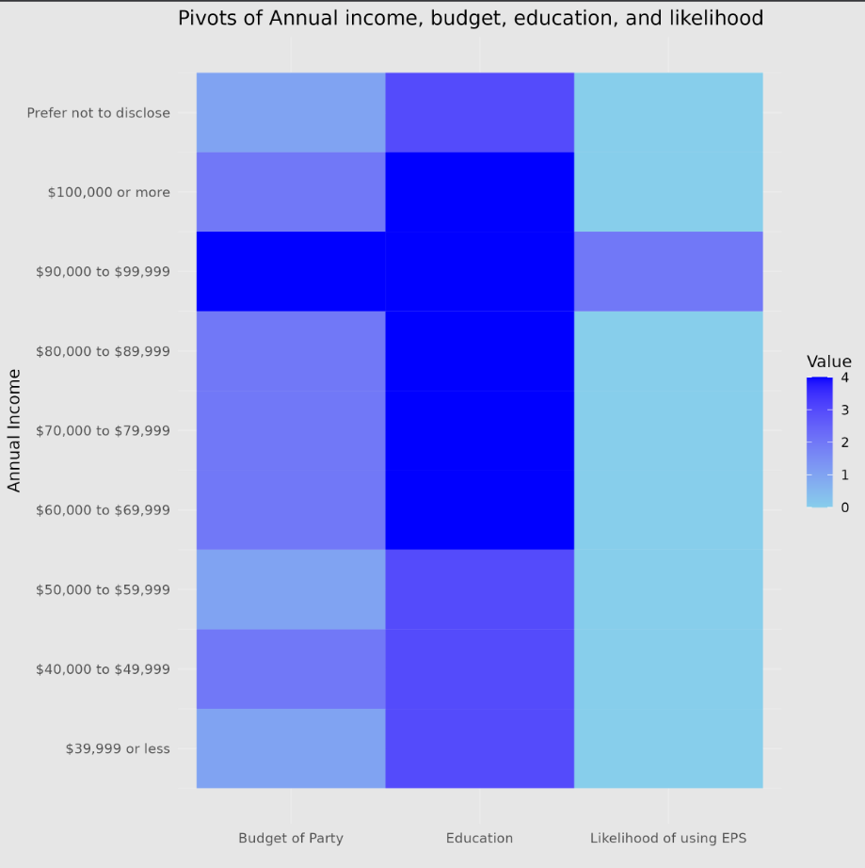

**3) Data insights:**

Below this text instruction line, insert at least three properly structured and arranged sentences **in written paragraph format** (grammar, spelling, sentence casing, use of spacing, symbols and punctuation) to compose some data insights that can be logically deduced from the DVs that you provided above and **that say something about the data with regard to the M5 theme of Group Comparisons**. If you write more than three sentences, be sure to use appropriate paragraphing structure for technical writing[1]. Do not remove this instruction block content. Removing any content from this template results in a 1 point penalty.

**Pivot values of Annual_income, budget, education and likelihood of using Elite party service:**

1. Individuals with larger annual earnings, such as "$3,000 or more," have a stronger proclivity ("Very Likely") to use Elite Party Services (EPS), indicating a positive relationship between income and service consumption.
2. Education Matters: Regardless of income, those with advanced education levels, such as "Doctorate" or "Master's degree or higher," are more likely to be "Very Likely" to utilize EPS. Those with less education, on the other hand, are more likely to be "Undecided" or "Likely."
3. Income-Education Nexus: The plot demonstrates the interaction between annual income and education in impacting the likelihood of utilizing EPS, emphasizing the significance of taking both elements into account when assessing customer preferences.

**Party preference by Ethnicity:**

1. Groups reported as Asian and African American ethnicities have close to 50% of Themed and Destination Party preference.
2. Groups reported as White ethnicities has largest themed party preference.

**MCIS 6333_002 – Data Visualization Programming**

**Fall 2023 Dr. Esther Ledelle Mead, Professor**

1. <https://developers.google.com/tech-writing/one/paragraphs>